* 1. Create an S3 Bucket, Upload & Access Files, And Host the Website  
  Result:  
  Display "K21Academy is one of the best places to learn cloud" after entering the URL

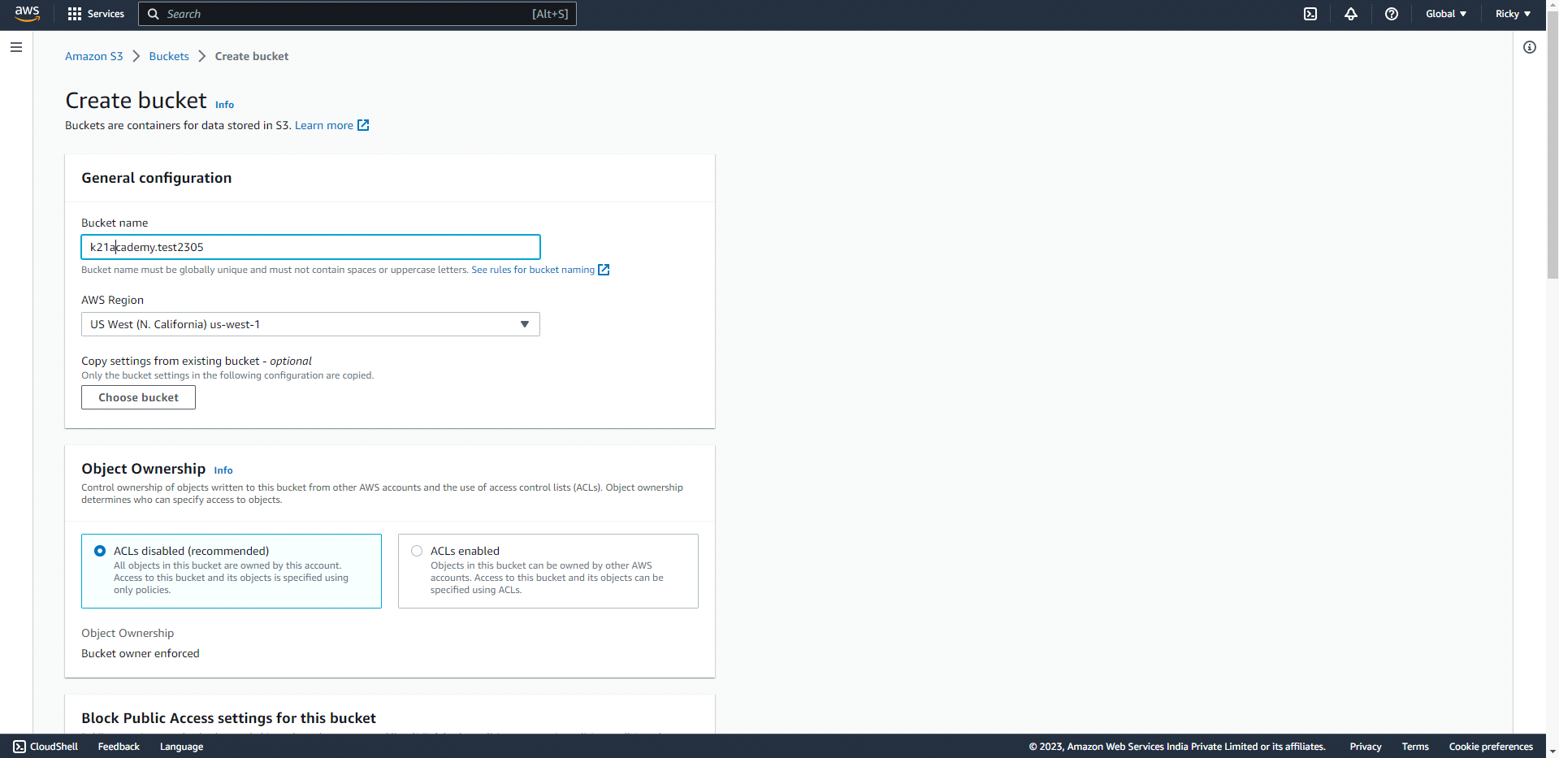

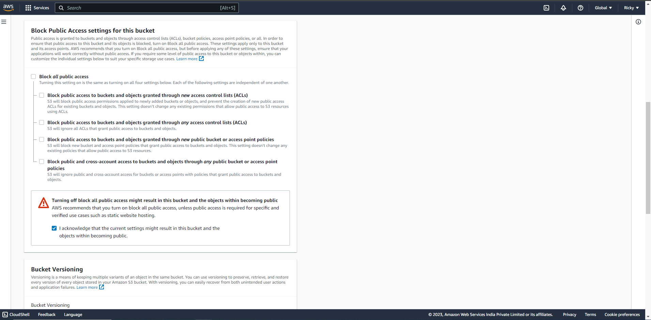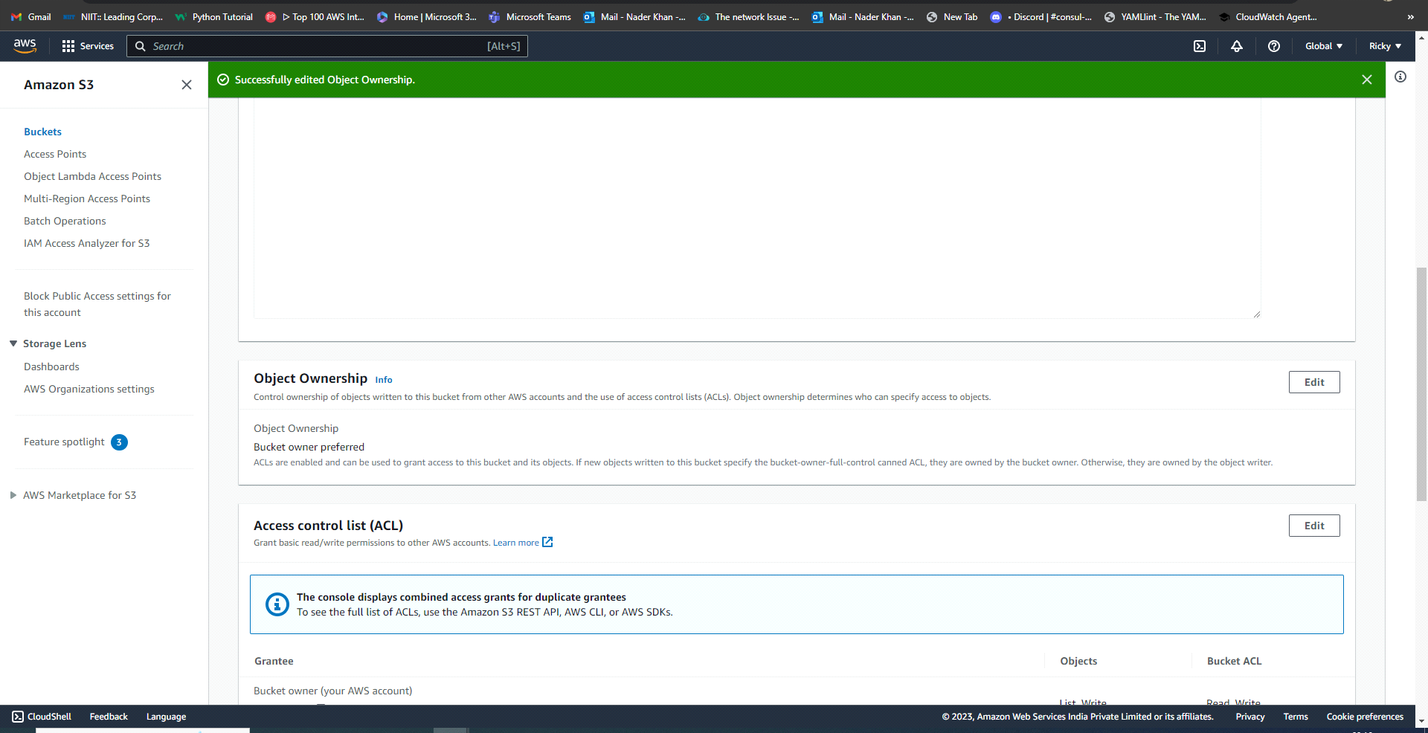

To create an S3 bucket-

* **Bucket name** - must be globally unique. There should not be an S3 bucket with the same name in any AWS account.
* **AWS Region**- The region in which the S3 bucket will be created.
* Block Public Access settings for this bucket- The html file inside our S3 will be accessed by the public. Hence, we need to uncheck the box
* Upload the html file. After the file is uploaded -  
   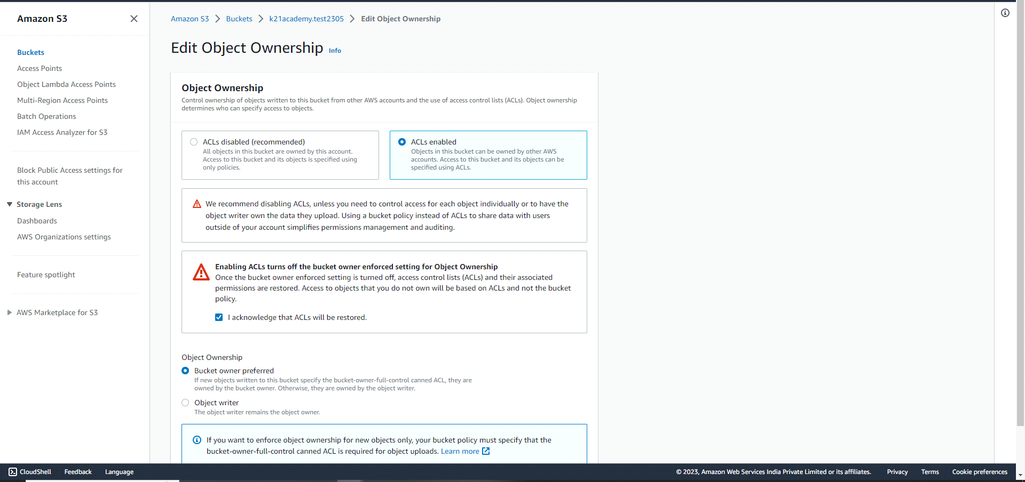
* **Object Ownership-** ACLs enabled

The ACLs are public because the user using the website might or might not be verified.   
  
 Select the index.html file.   
 Click on Action.   
 Make the ACL public.  
   
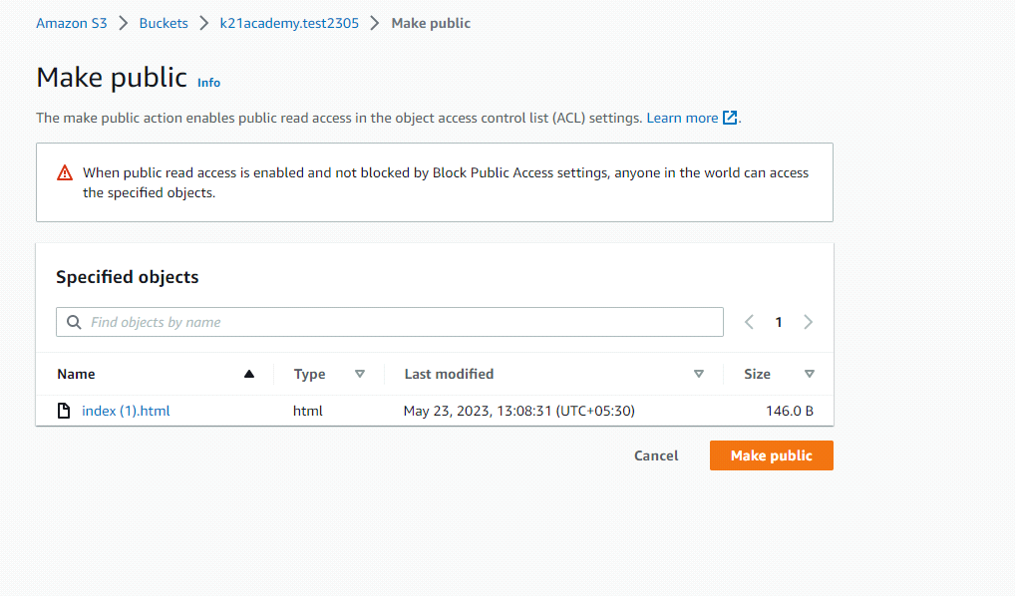

* Click Enabling static website hosting-

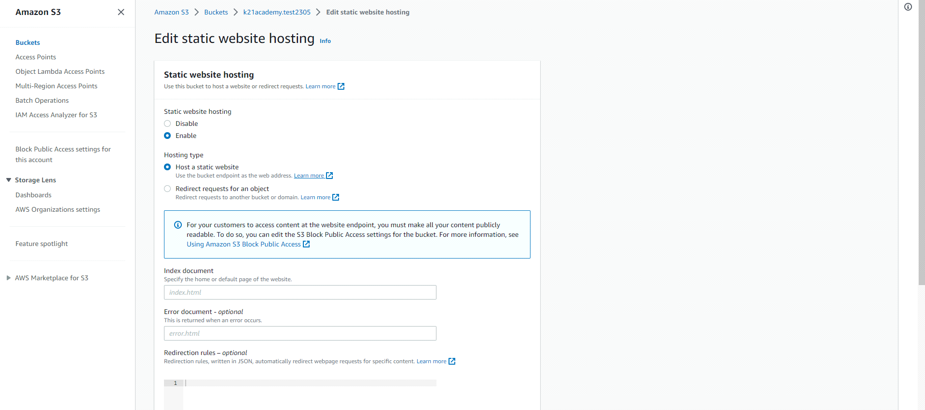

* To Enabling static website hosting-
* Select the on the uploaded html file.  
  Click on “**Properties**”  
  Scroll down click on “ **Static website hosting”**  
  Enable static website hosting and name the “Index document” then click on save changes.
* Now copy the “Object URL” and paste it in any browse the html file will appear.

